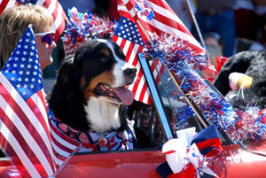
ATTN DOG LOVERS

Looking for friendly dogs and their owners for the Glen Rock 4th of July parade.
We will have a small dog group and a large dog group walking in the parade which starts at 9:30 AM. Please join us at the beginning of the parade but add-ons during the parade are welcomed on short leashes.
Please RSVP for details:
Patti McHugh phmchugh906@gmail.com or
Christine McKinney Pfeiffer pfeifferpfam@gmail.com

Raising $$$ and awareness for the Glen Rock Dog Park!

