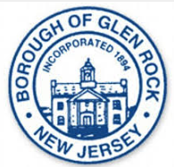
Glen Rock Environmental Commission
Meeting – Wednesday, Jan. 16, 2019

TOPIC: Glen Rock Dog Park
Sustainable NJ Grant Application and/or info for other potential grants

- Municipality Information
• €Municipality Name GLEN ROCK
• €County BERGEN
• €Municipal Employer Identification Number (EIN) - 22-6001836
- Grant Proposal
• €Grant Funding Requested: $20,000 (or whatever max grant amount is)
ECO-FRIENDLY GLEN ROCK NJ DOG PARK – COMPANION ANIMAL / INNOVATIVE COMMUNITY
ESTABLISHED NON-PROFIT WORKING WITH THE GLEN ROCK MUNICIPAL GOVERNMENT AND COMMUNITY VOLUNTEERS TO CREATE AN ECO-FRIENDLY, ASTHETICALLY PLEASING, COMMUNITY FRIENDLY, ADA COMPLIANT DOG PARK IN GLEN ROCK, NEW JERSEY UTILIZING UNUSED LAND BEHIND THE CURRENT RECYCLING CENTER. THE DOG PARK WILL INCORPORATE LEADING EDGE RECYCLING AND ENERGY CONSERVATION PRACTICES (METHANE DIGESTER, SOLAR PANELS, AND SOLAR CHARGING STATIONS) THAT WILL SERVE AS A CATALYST FOR AWARENESS AND IMPLEMENTATION ACROSS OTHER NEW JERSEY COMMUNITIES. IN ADDITION. THE PARK WILL HOST PET WELLNESS SEMINARS, COMPANION ANIMAL TRAINING AND OTHER EVENTS. THE DOG PARK WILL BE DEDICATED TO THE 9/11 SEARCH AND RESCUE DOGS.
OVERVIEW
- PHASE I of Dog Park Implementation
  - Architecture
  - Landscaping
  - Fencing
  - Initial Signage
  - 9/11 Search and Rescue Dog Memorial
  - Basic amenities
  - Initial ADA accessibility
- Conduct 9/11 Memorial Event / Awareness Event at Glen Rock Dog Park

- PHASE II and III of Dog Park Implementation
  - Installation of eco-friendly leading edge Dog Park enhancements
    - Methane Digester to recycle dog water into energy
    - Solar Powered Charging Stations
  - Enhanced Landscaping
  - Enhanced amenities
  - Enhanced ADA accessibility/amenities (i.e. additional paths, water fountains, shaded areas)
  - Security Cameras
  - Gazebo
  - Bulletin Boards
  - Agility Equipment Section
  - Enhanced seating/picnic areas
  - Enhanced Landscaping (i.e. Custom tile wall /art displays built by the Community)
NOTE: * Phases II and III implementation occurs as required funds are raised.
There are several components of this project:
- Creation of a Dog Park in Glen Rock, NJ
- Inclusion of leading-edge environmentally conscious recycling and energy solutions that will serve as a catalyst for implementation across other New Jersey communities.
- Education, training and volunteer opportunities.
- Dedication of the park to the 9/11 Search and Rescue Dogs
The leading edge recycling and energy (sustainability) components, namely the methane digester (to recycle dog waste into energy) and the unique solar powered cell charging station, would likely not be in scope if we do not receive grants due to the cost of research and implementation. The actual creation of the Dog Park will happen this Spring, but in a scaled down manner without additional funds/grants.
The agreement between the municipality and Glen Rock Dog Park Inc. is that the park must be entirely privately funded. Given the volunteerism, partnerships and donations (both $ and “in-kind”) collected to date, we are confident the park will be a reality. Other funding sources include: individual donors, local community donations (i.e. TD Bank, Private Foundation Donors), local organizations supporting our effort (i.e. Girl Scouts, Rotary Club) , Corporate Sponsors/Company match of individual donations, local businesses and dog-product related advertisers. Grants go a long way towards bringing this to fruition much more quickly.
The Borough of Glen Rock has always been very committed to sustainability efforts. Glen Rock has an Environment Commission and G.R.E.E.N. team in place and is currently certified as a Silver member of Sustainable New Jersey. Our proposal the potential to add 30 points to Glen Rock’s total sustainability points, augmenting current sustainability efforts.
The Glen Rock Dog Park Inc., a 501(c)(3) non-profit charitable organization established for this purpose, will continue to raise funds in perpetuity to sustain the park.

BACKGROUND
The idea for this Dog Park dedicated to the 9/11 S&R Dogs was initiated just over 5 years ago by our Founder and CEO, Michelle Hillock, then age 15, for her Girl Scout Gold Award. The Glen Rock Council shelved the request at that time. Michelle subsequently started a petition and garnered 600+ signatures enough to have the Mayor and Council reconsider their stance and approve the concept in August 2015 and pass a resolution on Dec. 9, 2015 providing borough land for the Dog Park with the stipulation that the park be entirely funded by private donations. An annual lease agreement was approved in 2018.
Since then we have been designated a 501(c)(3) non-profit by the Internal Revenue Service (IRS). Our residents (over 1000 dogs registered in Glen Rock) and local businesses have been supportive in hosting and participating in fundraisers and sponsorship opportunities. We also apply for grants as opportunities arise.

NJ Sustainability Program Applications:
Companion Animal Management Plan 10 Points
Innovative Community Project 1 10 Points
Innovative Community Project 2 10 Points

Up to 30 points towards Glen Rock's Sustainability certification.

1) Companion Animal Management Plan 10 Points

Create a Glen Rock Dog Park - a fenced-in, off-leash dog park where dogs can exercise in a clean, safe environment without endangering or annoying people, property, or wildlife.

Working with the recently formed Glen Rock Dog Park Inc., a 501(c)(3) non-profit organization in partnership with the Community, the Borough Council and local Businesses, the park is a community project designed to satisfy the needs of both dog owners and non-dog owners.

Our mission is to promote education, training, and recreational activities in an eco-friendly environment that facilitates environmentally friendly practices, civic pride, responsible dog ownership and better-behaved dogs through the use of volunteers and professionals.

The eco-friendly and ADA compliant park will be open seven days per week from 8 a.m. until dusk.

2) Innovative Community Project 1 10 Points

This Dog Park project will showcase new approaches to sustainability issues by implementing innovative approaches to:
- Resource Conservation
- Waste Management

We will be working on a joint internship program with Massachusetts Institute of Technology (M.I.T.) to research, design and implement a “Park Spark” methane digester to recycle dog waste into an energy source. We will also work with M.I.T. to develop an educational component that promotes public awareness of this project as well as the benefits and use of biodegradable dog waste bags.
Articles on PARK SPARK
http://parksparkproject.com/home.html
How it Works: http://parksparkproject.com/artwork/1206505.html

Anaerobic Digester
http://phys.org/news/2010-09-dog-lit-poop.html
http://www.govtech.com/technology/Pet-Poop-Fueling-City-Park-Light.html
http://www.cowpattypatty.com/?p=511
http://phys.org/news/2010-09-dog-lit-poop.html

3) Innovative Community Project 2 10 Points

Our project will showcase new approaches to sustainability issues by implementing innovative approaches to:
- Resource Conservation
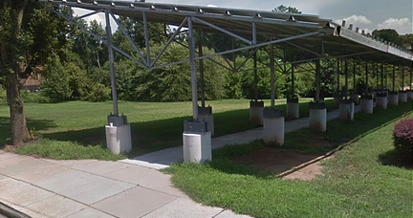
- Development /Landscaping
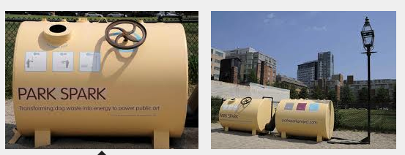
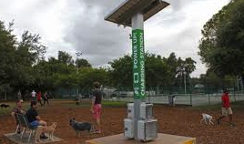
Working with various vendors to install solar powered cell charging stations at the Dog Park. This will reduce electric consumption while encouraging community members to frequent the dog park with their pets and hopefully stay longer to enjoy it (while their devices are charging!).
Each of these projects allows us to leverage Community and other resources - Borough Council, Environmental Committee and G.R.E.E.N. team, Resident Volunteers, Professionals, Scout Groups, High School students and MIT College students. Placing the “Park Spark” methane digester (to harness the energy created from dog waste) and the solar powered cell charging stations in the Dog Park are unique and innovative ideas that can be replicated across other areas of New Jersey and the United States. Each of our projects affect a large demographic as the Dog Park is a multi-generational recreational area that can be used by all citizens – dog owners as well as non-dog owners. In addition, the park will be dedicated to the 9/11 Search and Rescue Dogs, making it a destination park as well.

BACKGROUND INFORMATION on the GLEN ROCK DOG PARK Inc.

Non-Profit

We are a 501(c)(3) non-profit charitable organization.
All donations are tax-deductable to the extent allowed by law.
EIN# 47-5005221

Glen Rock Dog Park Inc.

Board Members:
Founder: Michelle Hillock
President: Eileen Maher Hillock
Vice President: Lisa Schor Babin
Treasurer: Linda Brennan
Secretary: Christine Pfeiffer
Strategic Initiatives: Christine and Jay Ross

Honorary Board Members:
2015 Mayor John Van Keuren
2015 Councilwoman Joan Orseck
Both of whom are key project supporters and instrumental in helping the team accomplish this goal.

